Childbirth Education class

Handouts

1

**Video One**

What to take to the hospital

**Video Two**

Anatomy and physiology

**Video Three**

All about vaginal delivery – What to expect

**Video Four**

Medical induction of labour

**Video Five**

Medical Interventions and how to make decisions in labour

**Video Six**

Medical Pain Management – Analgesics, Nitrous Oxide, Epidurals

**Video Seven**

Caesarean Sections – Reasons for a surgical birth and what to expect

**Video Eight**

Baby’s first 24 hours after birth

**Video Nine**

Postpartum Recovery – your physical and mental healing after birth

**Video Ten**

Birth planning session – creating a wish list for your birth

**Symptoms To Report To Your Health Care Provider**

If you experience any of the following symptoms during your pregnancy, report them to your doctor right away:

* Vaginal Bleeding
* Leaking or gushing of fluid from the vagina
* Sudden puffiness or swelling of the hands, face or feet
* Server persistent headache
* Disturbance of vision – spots, flashes or blind spots
* Dizziness, light-headedness
* Pain or burning sensation upon urination
* Irritating vaginal discharge, genital sores or itching
* Fever – oral temperature over 100 degrees F
* Persistent nausea or vomiting
* Noticeable reduction in fetal activity

**Video Two - Anatomy Game**

Before watching the video, see how many you can match up

**_____ Amniotic Fluid**

**_____ Amniotic Sac**

**_____ Bladder**

**_____ Cervix**

**_____ Fundus**

**_____ Mucous Plug**

**_____ Perineum**

**_____ Placenta**

**_____ Pubic Bone**

**_____ Rectum**

**_____ Spine**

**_____ Umbilical Cord**

**_____ Uterus**

**_____ Vaginal Canal**

**Anatomy And Physiology Terminology.** 4

**Amniotic Fluid**

* The “water” that your baby lives inside of to maintain temperature and cushion baby
* When your “water breaks” this is the fluid that flows out

**Amniotic Sac**

* The strong membrane that holds the amniotic fluid and baby

**Bladder**

* The organ that holds urine before it is eliminated from the body
* You may have felt pressure on your bladder during your pregnancy
* This pressure may increase as you get closer to your birth date as baby drops into the pelvis

**Cervix**

* The bottom portion of the uterus
* The cervix will need to soften, shorten and open in order for baby to be born

**Fundus**

* The top portion of the uterus
* The ‘Fundal Height’ is measured from the pubic bone to the fundus. This gives a good assessment of the baby’s growth

**Mucous Plug**

* A plug of mucous that sits inside the cervix, held by the pressure of the closed cervix and protects the baby from infection from the outside world
* The mucous plug will fall out of the body as you get closer to your labour. Some women will notice this and some will not

**Perineum**

* The area of tissue between the vagina and the anus
* This area will be stretched as needed for the baby to be born

**Pubic Bone**

* The front bones of your pelvis under which your baby needs to pass in order to be born

**Rectum**

* The body part in which feces is expelled
* You will most likely feel pressure in your rectum as your baby’s head makes its way down the birth canal

5

**Spine**

* Part of your central nervous system
* Some women experience back aches during the last part of pregnancy. This is usually due to the weight of the baby throwing the mother’s posture off. Be aware of your posture and try not to overcompensate for the shift in gravity.

**Umbilical Cord**

* The fleshy cord that connects the baby to the mother
* Blood, oxygen and nutrients pass from mother to baby and waste products pass from baby to mother

**Uterus**

* The muscle that contains the baby as it grows

**Vaginal Canal**

* The birth canal

6

7

**Video Three - The Birth Process**

The chart below describes the stages and phases of labour and give you some suggestions that might be helpful. Labour progresses over time and birthing parents will move through these stages and phases differently. Some birthing parents may have a long pre-labour and a very short active phase; while for others the labour may progress slowly through all the phases. It is important that you stay as relaxed as possible and allow your labour to progress at its own pace.

Trust that it will be accomplished in its own time.

|  |  |  |  |
| --- | --- | --- | --- |
| **Stages/**  **Phases** | **What is Happening** | **What You May Feel** | **What You Can Do** |
| Pre-Labour | Contractions are off and on, you are producing hormones (Oxytocin) that soften and thing (efface) your cervix. | You may feel nauseated, have loose bowels, low back ache and/or may have a “burst of energy”. You may lose your mucous plug. Your “Braxton Hicks” may increase in frequency. | During the day continue with your normal activities. At night, have a warm bath and try to sleep.  Eat whenever you are hungry, make sure that you drink a glass of juice or water every hour. Don’t count every contraction – try to ignore them until they are very strong and in a pattern. |
| First Stage:  Latent Phase | Contractions become regular, closer together and stronger. Your cervix softens, thins (becomes effaced), and opens (dilates) to come 5-6 centimeters. | Contractions may feel like strong menstrual cramps, backache may become stronger, you may feel excited, relieved or anxious. | As above. Focus on remaining as relaxed as possible. Along with your partner you can: listen to music, read, take a bath, go for a walk, watch a movie, play cards, time contractions on and off. Call the labour unit if you are wondering if you need to come in to the hospital. (416)864-5252  Remember 3-1-1  When your contractions are approx. 3 mins apart, lasting about a minute for approx. an hour. |
| First Stage:  Active  Phase | Contractions become much stronger, may last 60 seconds, and are close together – every 3-4 minutes or less. Your cervix dilates to 8 centimeters. You may have an increase in bloody discharge (show) and your membranes (bag of water) may break. Your natural pain relievers (endorphins) increase. This phase may be as short as 30 minutes or as long as 6 hours. | The contractions may become quite painful. It will take some concentration to handle them. You may feel very drowsy from the increase in endorphins. You may feel a little discouraged and panicked as the reality of labour sinks in. | Partner: The birthing parent will need your undivided attention and support throughout each contraction. You can: breath with them, massage their back, legs, arms; help to change positions and use the tub; use warm/cold cloths on the back and neck, play soft music, help rest between contractions, offer drinks between contractions, help them focus on using counting, a focal point or imagery. |
|  | **What is Happening** | **What You May Feel** | **What You Can Do** |
| First Stage:  Transition | Your cervix opens to 10 centimeters (full dilation)  May last 10 to 120 minutes.  Contractions are very intense and painful. They are about 1-2 minutes apart and may last up to 90 seconds. The baby may begin to move down the birth canal, increasing pressure on the bladder and bowels. | You may feel overwhelmed, restless, nauseated, hot and cold. You may cry out, tremble, weep and or fall asleep between contractions. You may feel like you cannot go on. | Continue to use all the comfort measures mentioned above. If on of the techniques has stopped working, use another one and then go back to a previous on. It may be effective again. |
| Second Stage | You may experience a resting period, when the contractions may slow for a while. The contractions will gradually increase in strength and frequency. Baby will begin to move down the birth canal. Baby will move down a little with each push, the slip back a little, then forward again. This is important to gently stretch the vaginal tissues, reducing chances of tearing. With time the baby’s head slips out, followed by the shoulders and the rest of the baby. | After being very drowsy during active and transitional labour, you may begin to feel very alert. The urge to push becomes stronger as the contractions progress, to the point where you cannot help pushing. You may feel strong pressure in the rectal area as well as burning around the vaginal opening (perineum) as the skin stretches. If you have had an epidural, the urge to push might not be as strong and you may need some coaching. | Partner: Remind the birthing parent that the resting stage is normal and encourage them to rest until the urge to push increases. Help them change positions about every 20 minutes. Remind them to relax their pelvic floor. Warm compresses may help with this and warm compresses on the perineum will decrease the burning sensation. Encourage them to “breathe the baby out” using the urges to push as a guide. If they find using their voice helpful, encourage them to use low deep sounds. Helping them use a mirror to watch or touch the baby’s head, can be helpful in focusing the pushing efforts. |
| Third Stage | The baby is rubbed vigorously with a blanket and placed skin to skin on your abdomen or chest. The cord is cut. The placenta is delivered. If you have had a tear or an episiotomy it will be repaired while you bond with your baby. | You might feel quite shaky. You may experience some cramping as the placenta separates. | Partner: Enjoy the baby, praise the birthing parent’s efforts. Take lots of pictures. |

*Adapted from*

*The Birth Partner by Penny Simkin*

9

**Relaxation in Labour**

In a book entitled “Childbirth Without Fear”, Dr. Grantly Dick-Read observed that when a birthing parent experiences fear during labour it caused the body to tense. This tension, he deduced, caused the birthing parent to experience greater discomfort and pain. This is known as the Fear-Tension-Pain Cycle.

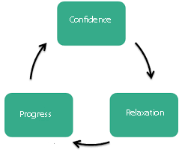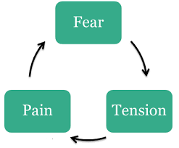

Before and during the labour it is important for the birthing parent to eliminate fear and practice the forms of relaxation that best suit them. As a support person, it will be important for them to assist in this relaxation so that the labour and the birthing parent can proceed with Confidence, Relaxation and Progress.

What can you do to “Relax”?

________________________________________________________________________________________________________________________________________________________________________________________________________________________________________________________________________________________________________________________________________________________________________________________________________________________________________________________________________________

10

**Breathing Strategies for Labour**

There are a number of ways to use breathing techniques to help with labour. Breathing methods can be use dot help relaxation, to distract you and to help you keep some control over the birth process. It is important to practice these techniques during pregnancy. Practice often so that you are comfortable with the use of different patterns before you go into labour. Practice with different rates and rhythms of breathing to find patterns that work well for you. In labour, let your comfort level be your guide in deciding how and in what order to use the patterns. Your labour support person should know the patterns as well so that they can help get you back on track if the labour discomfort makes it hard to manage on your own.

Breathing techniques are only one of many tools that you can use during the labour. Some birthing parents find that slow breathing is all they need. Others will find that their breathing speeds up on its own. Some find the use of transitional or pattern-paced breathing very helpful while other birthing parents cannot work with patterns. Practice will help you find what works well for you.

**The Breathing**

As each contraction begins, take a deep “Cleansing Breath”. Breathe in fully and breath out as fully as you can. This cleansing breath prepares you for the contraction and is a cue to your support person that you are beginning a contraction. As you take your big breath in, through your nose, imagine there is a balloon in your belly and expand your belly with each breath in. Expanding your diaphragm with each breath in. There should be more movement in your abdomen than your chest. As you breathe out, relax your body. Breathe out long and fully. At the end of the contraction, take another cleansing breath and relax all the tension from your body. Keep your eyes closed and scan your body for tension and release those spots where you find any tension.

As the contractions intensify, you may find breathing in slowly and deeply is more difficult. Using a rhythmic pattern breath may help. The breathing may not be as deep and may speed up but try to avoid rapid breathing they may lead to hyperventilation. Your support person can breathe with you to keep the rhythm and avoid hyperventilation. Breathing in a “hee hoo, hee hoo” pattern can help focus your attention.

**Using a Focal Point**

Attention focusing takes your mind off the pain much the same way as breathing patterns.

You can:

* Focus on your partner, a picture or a spot on the wall
* Concentrate on your support persons’ voice, music or other soothing sound
* Concentrate on your support persons touch or massage
* Have your support person count your breaths and concentrate on the numbers
* Repeat a positive statement such as “I know I can” or “One breath at a time”

Begin each contraction in a comfortable position. Whenever you are breathing through a contraction, try to relax your body. Each time you breathe out at the end of the contraction, let your body sink a little deeper into this relaxed position.

12

**Reasons to Use The Birth Ball During Labour:**

* Its use facilitates physiologic positions for labour.
* It encourages fetal decent
* It assists in rotation of the baby in the posterior position
* It allows for pelvic rocking and body movements
* It encourages rhythmic movement
* It helps relieve back pain
* It can be used with both external and internal electronic fetal monitoring
* It provides perineal support without undue pressure
* It takes advantage of gravity during and between contractions
* There is less strain on wrists and hands when in the hands and knees position.
* It helps when a back rub or back pressure is needed
* The ball may enhance rotation and descent in a difficult birth
* The ball can be used as a support while squatting
* Its use helps widen the pelvic outlet to its maximum dimension when used during second stage
* It eliminates hard external pressure of a bed, chair or rocker when sitting
* It allows freedom to shift weight for comfort
* It helps take the pressure off hemorrhoids
* It encourages good physiologic positioning while resting
* It may speed up labour
* It helps contractions to be less painful and more productive
* It is beneficial with other techniques when a labour has stalled

12

**Hydrotherapy**

Water therapy in the form of tubs and showers are a great way to help with pain management and relaxation in labour. Just as a warm bath can relax you when you are stressed, a warm bath in labour can be a wonderful place to spend some time.

How does it work?

Warm baths help relieve discomfort in several ways:

* The buoyancy of the water takes pressure off your joints
* Warm water is relaxing
* The warmth, pressure and flow of water through the jets decreases the transmission of pain signals.
* The tub may not be comfortable after a while; however, you can use it more than once and it will be effective again.

When can I use the tub?

**At Home –** The tub or shower is great to use when you are having those pre or early labour contractions.

**In Hospital –** In active labour, you can use the tub or shower at any time, even if your waters have broken, as long as you have not had any pain relief medication.

Important Points

* The temperature of the water should be at body temperature or just above – Not Hot.
* In the hospital, you should not be left alone in the tub – the nurse will be in and out to check on you, but your partner, support person or doula should stay with you all the time.
* Your nurse will help you out of the tub when you begin to feel like pushing
* Make sure you are drinking fluids while in the tub

13

Massage in Labour

The key to labour is to relax the body while the uterus does the work. Massage during labour causes the body to release endorphins, which is the body’s own natural relaxant and pain killer. In addition, massage and appropriate touch during labour may positively affect the way the birthing parent interacts and touches the baby.

Key points for the support person to remember when massaging:

* Try to maintain constant contact during the contraction.
* Make the movements rhythmic and smooth
* Pay attention to all parts of the body, especially hips, thighs, low back, head & neck
* Look for areas of tension
* Make sure the birthing parent is in a comfortable position and adjust pillows where needed
* For the support person, use good body mechanics to avoid injury or strain on your own back, neck, wrists or hands
* Center yourself and have positive thoughts while you maintain contact
* Massage over clothing or use a lubricant as skin can be come sensitive during labour
* Keep your hands warm
* Check in with the birthing parent periodically to check on pressure and what feels good
* Use medium to firm pressure

Suggestions for massage:

Back – using the tips of your fingers or the backs of your fingers begin rhythmic medium pressure movement up and down the back on either side of the spine. Maintain constant contact during the contraction so the birthing parent can get into a “zone” with the rhythm of the massage.

Counter Pressure – Can be helpful when the birthing parent is experiencing intense lower backache. Using your palms or fists on either side of the lower back near the tailbone and push as hard as the birthing parent needs. Using tennis balls in the same location can add extra pressure without adding extra stress on your wrists and hands.

Double Hip Squeeze – With the birthing parent leaning forward or on all fours, find the solid hip bones by feeling the upper portion of the buttocks. Once found using the palms of the hand on each side squeeze the hips together. This can help open up the front of the pelvis to aid in baby’s decent or get into a better position.

Medical Interventions – Video Five Understanding Medical Procedures

|  |  |  |  |  |
| --- | --- | --- | --- | --- |
| Method | How It’s Done | Why It’s Done/  Benefits | Risks To Mom | Risks To Baby |
|  |  |  |  |  |
| **Pitocin** | Medicine added to an IV | Too far past due date  Water breaks without contractions  Pregnancy has put you or baby at risk | Increased chance of cesarean birth  Increased labour discomfort | Fetal Distress |
| **Amniotomy** | Bag of waters is broken with an amni-hook during a vaginal exam | For a labour that has slowed down  Need for stronger, more frequent contractions | Doesn’t always shorten labour  Infection  Pitocin often needed | Fetal Distress  Infection |
| **IV Fluids** | Catheter inserted in a vein in the wrist or hand to administer fluid or medicine | If the laboring woman has become dehydrated  If medicine needs to be administered | Over hydration  Difficult to get into comfortable positions for labouring | Over hydration |
| **Vaginal Exam** | Care Provider uses hand inserted into the vagina to examine the cervix | To obtain information about the cervix. Specifically, the dilation, effacement and pelvic station | Infection  Disappointment that you are not as dilated as you think you are | No significant risks to baby if waters are intact.  If water has broken there is a risk of infection |
| **External Fetal**  **Monitoring** | Sensors are placed at the top of the abdomen and lower abdomen. Held in placed by stretchy bands | To obtain information about the contractions and fetal heart rate | Continuous monitoring tethers laboring woman to a machine.  Limits position changes for comfort | No significant risks to baby are known |
| **Internal Fetal**  **Monitoring** | Sensor is placed on the top of the abdomen to measure contractions. A scalp clip is placed on baby’s head to measure baby’s heart rate | To obtain an accurate and isolated view of baby’s heart rate | Must stay in bed which can limit position changes and comfort measures  Infection | Infection  “nick” on baby’s head |

Understanding Medical Procedures

|  |  |  |  |  |
| --- | --- | --- | --- | --- |
| Method | How It’s Done | Why It’s Done/  Benefits | Risks To Mom | Risks To Baby |
|  |  |  |  |  |
| **Episiotomy** | Surgical incision in the perineum between the vaginal opening and the rectum | To widen the vaginal opening to make more space for baby or if an instrumental delivery is necessary | Infection  Possible longer recovery | No significant risks to the baby are known |
| **Vacuum**  **Extraction** | A suction cup and pump that helps the delivery of the baby | If the laboring women is too tired to push  If baby needs to be born quickly | Episiotomy may be needed | Bruising and swelling on baby’s head  Admission to the Neonatal unit |
| **Forceps** | An instrument shaped like tongs to help guide baby out | If laboring women is too tired to push  If baby needs to be born quickly | Episiotomy may be needed  Possible damage to the vaginal canal | Temporary marks/bruising on baby’s face or head  Admission to the Neonatal Unit |
| Adapted from Injoy Video | Understanding Birth 2nd Edition |  |  |  |

Perineal Massage 16

This is adapted from the book “The Birth Partner” by Penny Simkin and is addressed to the support person, not the birthing parent. The “you” therefore refers to the birth partner.

Regular massage of the perineum (the area between the vaginal opening and the rectum) in late pregnancy can help prepare the perineum to stretch well during the birth. Massage during pregnancy can lessen the chances that the area will tear during the birth. It also helps the birthing parent feel the sensations that are like those they will feel when the baby is coming out of the vaginal opening and gives them a chance to practice relaxing this area as they would during delivery.

Perineal massage can be started about three weeks before the baby is due. Some birthing parents do not want to do this though others will find it pleasurable and sexually stimulating. Most who do it regularly find it very helpful.

**IMPORTANT: If the birth parent has vaginitis, a herpes sore or other vaginal problems, perineal massage could make the problem worse or spread the condition and should not be done until the problem goes away.**

Instructions for Perineal Massage

Either you or the birthing parent can do the massage. They directions are for you the birth partner. Be sure your fingernails are short. Wash your hands before beginning. If you have rough skin on your fingers which might scratch, wear disposable gloves.

The birthing parent should make themselves comfortable in a semi-sitting position with their legs bent and relaxed.

1. Lubricate your fingers well with olive oil, coconut oil or a water soluble jelly. DO NOT use baby oil, mineral oil or petroleum jelly as they can dry the tissues. Squirt the oil on your fingers, do not dip your fingers into the oil as it will put germs in the oil.
2. Rub enough oil or jelly into the perineum to let your fingers move smoothly over the tissue and lower vaginal wall.
3. Use your index (first) fingers. Start with one then move to using both. Put your fingers well inside the birthing parents’ vagina (up to the second knuckle) move them in opposite directions upward along the sides and lower border while outward gently. Do this for about three minutes. This movement will stretch the vaginal tissue, the muscles surrounding the vagina and the skin of the perineum.
4. Finish the massage by rubbing the skin of the perineum between the thumb and forefinger (thumb on the outside, finger on the inside) for about one minute. In the beginning, the tissue feels tight, but with time and repeated massage, it relaxes and stretches. The massage should take about five minutes.
5. The birthing parent to concentrate on relaxing the perineum as they feel the pressure. As they become more comfortable with the massage, increase the pressure just enough to make the perineum begin to sting from the stretching. This same stinging feeling will happen as the baby’s head is being born.
6. If you have questions after you have tried the massage, you can ask your caregiver or your childbirth educator.

Video Six - Medical Pain Management for Childbirth

|  |  |  |  |
| --- | --- | --- | --- |
|  | Analgesics | Nitrous Oxide | Epidural |
| Definition | Narcotic medication that takes the edge off of the pain, but does not completely remove it. | An anaesthetic gas mixed with oxygen breathed into the lungs to take the edge off the pain of contractions | Regional anesthetic that removes sensation in the abdomen, lower back and pelvic area |
| Administration | Health care provider injects a dose of medication into an IV or the muscle of the thigh  Usual not given once Active Labour has started | Inhaled through a mask which is held by the birthing parent during a contraction.  Usually not given until transition or pushing stages | An anesthesiologist places and epidural catheter in your lower back, below the spinal cord. A mixture of anesthetics and narcotics will flow to the area through the catheter by continuous infusion. |
| Benefits | * Can be given right away in early labour * Works immediately to dull pain sensation * Medicine doesn’t numb your muscles, allowing you to move around after it wears off * Analgesics provide enough relaxation for you to sleep between contractions | * Provides some pain relief * You are able to remain awake and in control * Does not interfere with contractions * The time Nitrous Oxide remains effective is short and there are no obvious short term effects on mother or baby. | * Very effective pain relief * You are able to remain awake and alert since the medicine doesn’t affect your brain * There is little to no effect on the baby |
| Risks to the Birthing Parent | * Can cause disorientation, dizziness or drowsiness * Your blood pressure may drop which could affect baby’s heart rate * May cause nausea and or itching * Can slow your breathing down requiring extra oxygen from an oxygen mask | * Nausea and or vomiting * Not a reliable form of pain relief * Can cause disorientation, dizziness or drowsiness * Face mask can be annoying or make you feel claustrophobic | * May not disperse evenly requiring an adjustment of the catheter or a position change * Low blood pressure * Itchiness, nausea * Shaking or chills * Increased risk of fever * Soreness at the administration site * Or more serious side effects. |
|  | Analgesics | Nitrous Oxide | Epidural |
| Risks to Baby | * Could be sleepy and less alert right after birth * May have difficulty breastfeeding because of sleepy state * Could have slowed breathing and reflexes after birth, which might need medication to treat | * No long term or short term side effects for baby are known at this time | * Current research does not indicate any significant risk to the baby |
| Effect on Labour | * Your mobility might be restricted while the medication is in effect because of the disorientation/dizziness you might feel and extra monitoring is required * Pain often feels more intense after the drug wears off since your body stops producing endorphins the help manage pain * Analgesics may not provide enough pain relief and additional doses might lose their effectiveness | * No effect on contractions or length of labour are known. | * You will need to stay in bed since your muscles are numb * Epidurals may affect labour progress, causing it to slow down or speed up, depending on your situation * You will need a urinary catheter since you won’t be able to get up to use the bathroom * You will need continuous fetal monitoring, a blood pressure cuff and IV fluids for the remainder of the labour and birth. * You may not feel the urge to push, requiring extra help from the hospital staff on when and how to push effectively * Increased risk of a delivery requiring a vacuum extraction or forceps. |

Adapted from Injoy Videos “Understanding Birth 2nd Edition”

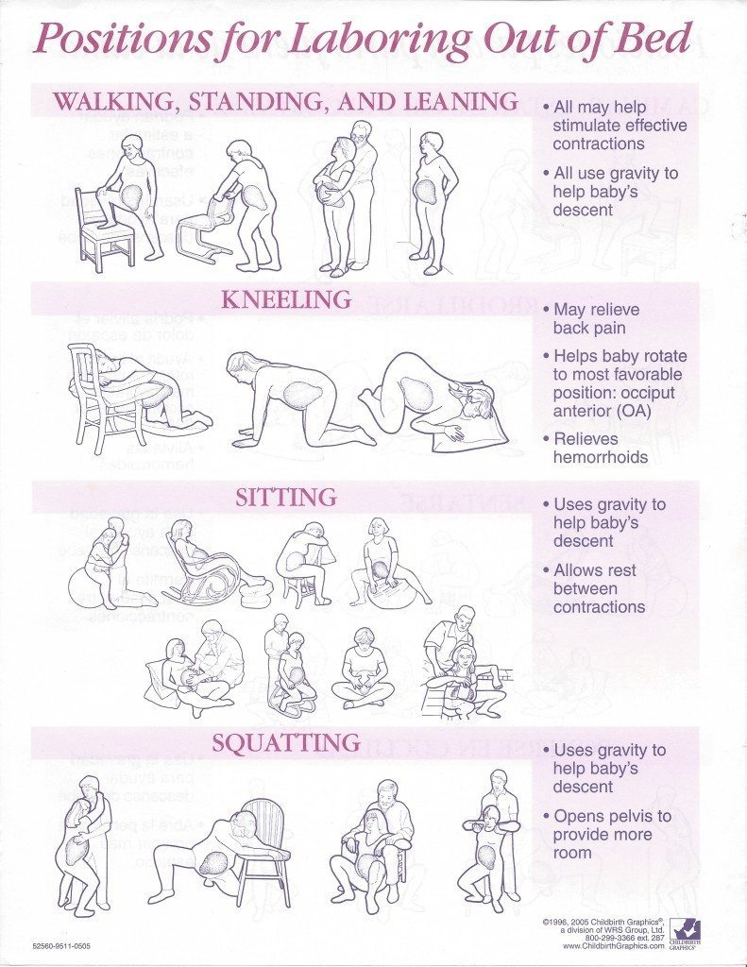

20

Checklist of Comfort Measures for Labour

Adapted from Penny Simkin, PT©2008

*Relaxation/Tension Release*

* During or between contractions
* Roving body check

*Patterned Breathing*

* Slow
* Light

*Bearing Down/Pushing*

* Avoid bearing down
* Spontaneous bearing down
* Directed pushing
* Prolonged (Purple) pushing if baby needs to be born quickly

*Massage/Touch*

* Back and shoulders
* Hands or Feet
* Still touch, stroking, hand-holding
* Acupressure

*Hydrotherapy*

* Bath/Whirlpool
* Shower

*Attention Focusing*

* Visual focus, focus on music or voice

*Mental Activity*

* Visualization/guided imagery
* Count off every 10 sec in contraction
* Count breaths
* Chant, mantra, song, counting, prayer
* Take Charge Routine

*Hot Packs/Warm packs*

* To lower abdomen or groin
* To perineum
* To low back

*Cold Packs*

* To low back
* To perineum right after birth

*Positions and Movements*

* Standing or leaning forward
* Walking, slow dancing
* The lunge (standing or kneeling)
* Sidelying/semi-sitting
* Flat on back (one side tilted at the hip)
* Squatting
* Supported squat or dangle
* Lap sitting

*Specific Backache Measures*

* Counterpressure
* Double hip squeeze
* Rolling pressure
* Hot/cold pack
* Shower spray on back
* Large bathtub (with room to kneel and lean over the side)
* Open knee-chest position
* Abdominal lifting
* Hands and knees with pelvic rock
* Kneeling, leaning forward on ball or chair
* Lunges (standing or kneeling)
* Walking, slow dancing

*Make sure to check with your care provider if any of these options may not be suitable during your labour.*

Video Seven – Surgical Birth

Caesarean births accounts for approximately 27% of deliveries at St Michael’s Hospital.

A caesarean birth is the surgical delivery of the baby through an incision in the birthing parent’s belly and uterus. Caesarean births are done if a vaginal birth is impossible or unsafe for the baby or the birthing parent.

Reasons for a surgical birth?

_________________________ ____________________ _______________________

_________________________ ____________________ _______________________

_________________________ ____________________ ______________________

* Unplanned caesarean births are performed when they become necessary during labour. If an unplanned caesarean becomes necessary, you will be given an epidural or your epidural will be topped up so you that you do not feel any pain during the procedure.
* Immediate emergency caesarean births only happen in about 1% of all births. In the case of an emergency, if an epidural is not already placed, general anesthesia is usually used, which means you would be asleep for the delivery.
* During a planned or unplanned caesarean birth, you will be allowed one support person to accompany you during the procedure.
* Delivering the baby surgically can take 5-10 mins. Once the baby is born, completing the procedure can take another 45mins to an hour. During that time your baby will be looked at by the health care team to ensure baby is healthy and does not need any special care.
* Once baby is deemed stable, they will be swaddled and given to your support person who can show you the baby and you can touch the baby.
* Often times you will not be able to hold your baby or do any skin to skin until the procedure is over, and you have been taken to recovery. But arrangements can be made for your support person/partner to do skin to skin while the procedure is being completed and after you have had a look, touch and kiss of the baby.

22

Notes

23

Video Eight - Baby’s First 24 hours

Take notes on what you learn

Newborn Procedures

Immediate Skin to Skin: _______________________________________________________

___________________________________________________________________________

___________________________________________________________________________

APGAR: ____________________________________________________________________

___________________________________________________________________________

___________________________________________________________________________

Cord Clamping: ______________________________________________________________

___________________________________________________________________________

___________________________________________________________________________

Eye Ointment: _______________________________________________________________

___________________________________________________________________________

___________________________________________________________________________

Vitamin K: __________________________________________________________________

___________________________________________________________________________

___________________________________________________________________________

Blood Tests: ________________________________________________________________

___________________________________________________________________________

___________________________________________________________________________

Hearing Test: ________________________________________________________________

___________________________________________________________________________

___________________________________________________________________________

___________________________________________________________________________

___________________________________________________________________________

______________________________________________________________________________________________________________________________________________________

___________________________________________________________________________

______________________________________________________________________________________________________________________________________________________

______________________________________________________________________________________________________________________________________________________

___________________________________________________________________________

**Video Ten - Birth Preferences Activity**

Before your labour and delivery begin or before your surgical birth preformed it’s important to understand what your options are. Now that you have taken the St. Michael’s Childbirth Education class you should be better equipped to make the best choices for you and your family.

Below jot down the options you would like to have during your birth. Recognizing that you and your baby’s health and safety will take precedence over these choices should an emergency situation arise.

Options for the Birth, Delivery, and The Immediate Postpartum Period

___________________________________________________________________________

___________________________________________________________________________

___________________________________________________________________________

___________________________________________________________________________

___________________________________________________________________________

___________________________________________________________________________

___________________________________________________________________________

___________________________________________________________________________

___________________________________________________________________________

___________________________________________________________________________

___________________________________________________________________________

___________________________________________________________________________

___________________________________________________________________________

___________________________________________________________________________

___________________________________________________________________________

___________________________________________________________________________

___________________________________________________________________________

Video One - What to Take to The Hospital

This is not a complete list. You must remember to bring items that will enhance your comfort and relaxation. A good idea too, is to pack three separate bags. One bag for labour which you will bring in with you when you arrive at the hospital. One bag for your stay at the hospital after you birth and one bag for baby. These last two bags can stay in the car so your partner doesn’t have to have their arms full so they can help you as well.

For Labour

* Your health card and hospital paperwork
* Robe, oversized t-shirt, yoga top or swim top
* Slippers, several pairs of socks, many pairs of underwear
* Glasses or contacts
* Unscented massage oil, lotion or talc/cornstarch for massage
* Tennis balls and massagers
* Lip balm
* Hair ties and elastics
* Cell phone and charger
* Phone lists of who to call with announcements
* Pillow, towel, blanket – all coloured so it doesn’t get mixed up with hospital linens
* Heating pad, ice bag
* Overnight sanitary pads
* iPod, speakers, camera
* toiletries
* snacks for you and your partner
* Change of clothes for your partner
* Magazine, deck of cards or tablet with movies
* Your Doula (Only Virtual Doula support is available during Covid-19)

After Birth

* Comfy sleep wear for in the hospital
* Loose comfortable clothing for going home
* Lots of old or cheaper large pairs of underwear
* Nursing bra and breast pads
* Overnight sanitary pads – lots!
* Ear plugs
* Several sleepers for baby, including hat, blanket and diaper shirts (depending on the time of year)
* Infant car seat (if you are driving home)
* Small package of newborn diapers, wipes and barrier cream
* A Pen!!!

27

Infant Feeding – Breast/Body feeding

Thinking about breast/body feeding?

There is a lot to think about when making your decision about breast/body feeding your new baby. In the end you must make the choice that you think will be the best for you and your family.

**Benefits for the breast/body feeding parent include:**

* Decreases bleeding after birth
* Your uterus goes back to normal sooner
* May help with weight loss
* Encourages closer bonding with baby
* Always ready to use and the perfect temperature
* Makes traveling easier – nothing to cart around with you.
* May help reduce the risk of breast cancer
* Helps reduce the risk of osteoporosis
* Saves money that would be spent on formula

**Benefits for baby include:**

* Perfect nutrition for your baby
* Easier to digest
* Breastmilk ingredients change as your baby gets older, so they grow and develop well
* May reduce the risk of SIDS (Sudden Infant Death Syndrome)
* Promotes proper development of the jaw and facial muscles
* Protects baby from many infections and illnesses (antibodies in breastmilk)
* May provide protection against childhood obesity and related diseases
* Prevents constipation
* Protects baby from developing ear infections

**How long will you Breast/body feed for?**

The World Health Organization recommends breastfeeding exclusively for the first six months of baby’s life, then starting first foods and continued breastfeeding for another two years.

Ultimately though, you get to decide the length of time that works best for you and your baby and family.

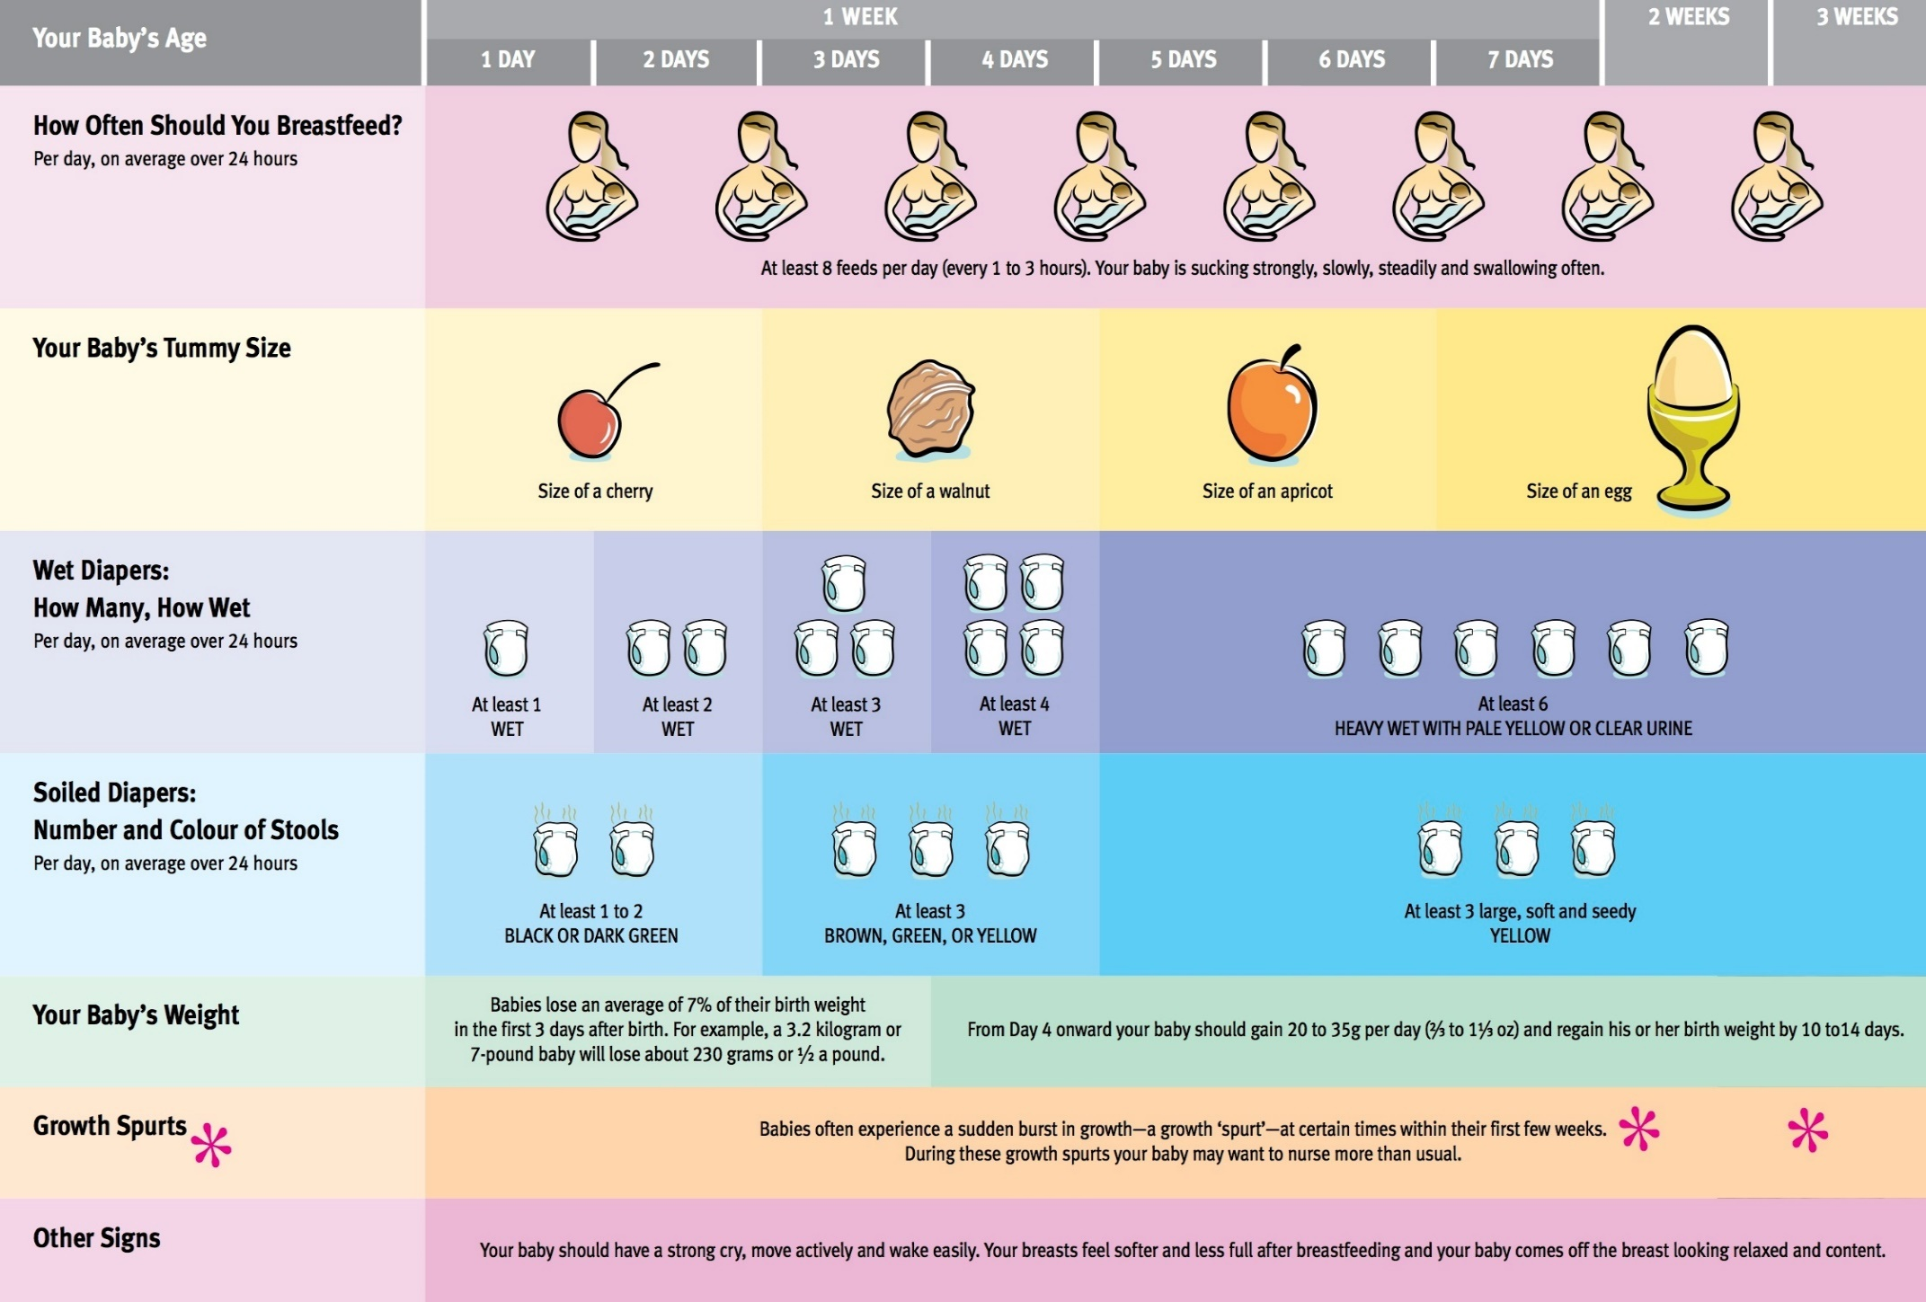

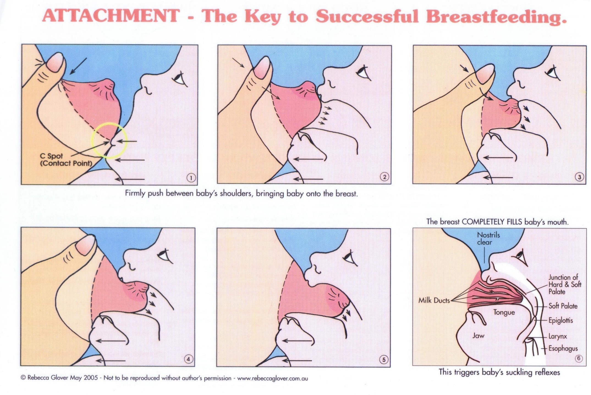

30

Breast/Body Milk Collection and Storage

Collecting Breast/Body Milk

* First, wash hands well.
* Wash breast pump equipment that connects the breast, milk or collection containers in a dishwasher or by hand in hot, soapy water. Rinse with cold water and air dry on a clean towel.
* When to pump depends on you and your baby’s schedule. Try to pump when the baby would normally feed. Or after you have fed baby at the breast for approximately 10 mins.
* Your milk supply is usually most plentiful in the morning. If your baby skips a feeding or nurses for a shorter time than usual or only nurses on one side, pump out the rest of the milk and save it.
* Never purposely skip a feed, remember to feed your baby on demand and pump off what baby does not take in.
* Before pumping, get comfortably seated and relaxed. Have a picture of the baby, or have something that smells like the baby or have a snuggle with the baby before hand if possible to stimulate the hormones needed for milk production and let down.

Storage

There are several containers available for storing breast milk. These include specially designed plastic bags, plastic bottles or glass containers. There are advantages to each.

1. If you are going to freeze your breast milk, leave some space at the top of the container. Breast milk, like most liquids, expands as it freezes.
2. When using plastic bags, use those designed for breast milk collection. Place smaller bags in a larger bag to help protect against punctures or leaking.
3. Mark the date and amount on each container. It is recommended that feed baby stored milk at the same time of day as the milk was pumped.
4. Freeze your milk in two to four ounce portions. Smaller amounts thaw quicker and you will waste less milk if your baby consumes less than you anticipated.
5. If you are only pumping small amounts of milk at a time you can continue to add milk to the same container throughout the day but make sure you are chilling the fresh milk before adding to the refrigerated stored milk. Then freeze when you have the appropriate amount. Never add warm milk to cold milk.

There are various options regarding the time breastmilk can be stored. St Michaels recommends:

Room Temperature 4-8 hours

Refrigerator 72 hours

Refrigerator Freezer (at the back) 3 months

Deep Freezer 6-8 months

Defrosting:

Place milk in refrigerator the night before you’re going to use it. Refrigerator defrosting can take 12 hours

OR place the milk under warm running water or in a pan of warm water. Don’t use hot water as this can destroy some of the milks important nutrients.

NEVER MICROWAVE BREAST MILK! Microwaving breast milk can change the milks composition, and has the potential to burn your baby’s mouth and throat.

Fat in breastmilk will separate and rise to the top. By gently swirling the container, you can mix any fat that may have separated. NEVER REFREEZE thawed breast milk. DISCARD any breastmilk you don’t use during a feeding.

31

For Partners/Support People Only

Ten Steps to Support Breast/Body feeding and Bond with Baby

1. Provide ongoing support to the breast/chest feeding parent
2. Act as a buffer between the breast/chest feeding parent and relatives or friends who may disapprove of breast/chest feeding
3. Play an active role in making decisions about baby’s health care
4. Hold your baby face to face; talk to them and touch them
5. Take your baby for walks in a stroller or infant carrier (wrap or sling)
6. Burp, diaper and play with your baby as much as possible
7. Learn to put your baby to sleep by letting them fall asleep on your shoulder or chest (Your warm chest and the sound of your heartbeat is a place of comfort and rest too.)
8. When your baby is fussy, walk, rock or sing to your baby
9. When the breast/chest feeding parent is tired, encourage them to rest and bring baby to them when the baby wakes.
10. Give the breast/chest feeding parent a break by taking care of baby in between feedings

NOTES

34

Video Nine - Postpartum Recovery

Physical Recovery:

**Lochia:** Bleeding called Lochia is normal after birth, whether baby was born vaginally or by a caesarean. For the first few days, the bleeding will be heavy but shouldn’t be heavy enough to soak more than one thick overnight pad an hour. IF YOU ARE SOAKING MORE THAN A PAD AN HOUR YOU NEED TO CONTACT YOUR CARE PROVIDER IMMEDIATELY

**Perineum Recovery:**  During a vaginal birth the perineum or the space between the vaginal opening and the rectum, becomes stretched and can tear, requiring stitches. Ice packs can be applied to ease the swelling and discomfort. At home you can make homemade ice packs as follows:

* Using a 50/50 combination of Water and Witch Hazel (a clear liquid used for hemorrhoids), soak a large overnight pad in the solution until the pad has absorbed as much as it can. Then take the pad and place it in a Ziploc freezer bag and pop it into the freezer to freeze. Once frozen it can be placed on the perineum for no longer than 10 mins and discarded after use. You should probably sit on a plastic or water proof mat while using the “Padcicle” to protect your bed or chair while it melts.
* This will also help with hemorrhoids which are common in pregnancy and birth.

Sits Baths will also aid in recovery. Either one you buy at a drug store or just sitting in a bath tub with several inches of warm water and Epsom salts.

**Medication:**  You will be given pain medication and stool softeners while you are in hospital. Follow the instructions and stay on top of the medication. The pain medication will help with the aches and pains that come after a very physical event like a vaginal or surgical birth. The stool softeners will help with those first few bowel movements that may be difficult, particularly after a vaginal birth.

**Things to Call Your Care Provider For:**

1. A Fever higher than 100.4 degrees F or 38 degrees C.
2. Difficulty urinating, emptying your bladder or pain while urinating
3. Bleeding that is very heavy, where you are needing to change an overnight pad more than once an hour
4. Large, difficult to pass blood clots, that are bigger than a golf ball.

35

Postpartum Recovery Continued…

Emotional Recovery:

|  |  |  |
| --- | --- | --- |
| Type | Symptoms | Risk Factors |
| Baby Blues:   * Affects 50-80% of birthing parents * Occurs within the first 3-5 days * Usually goes away within 1-2 weeks | * Crying, feeling sad * Feeling frustrated * Feeling tired * Difficulty concentrating * Difficulty sleeping | * Previous postpartum mood disorder * History of severe premenstrual syndrome * Unpleasant pregnancy * Previous miscarriage or infertility |
| Postpartum Depression   * Affects 10-20% of birthing parents * May start suddenly or slowly * Can occur any time within the first year after the birth of your baby or during pregnancy | * Crying, irritability * Exhaustion * Appetite changes * Feelings of doubt about parenting * Guilt * Feeling overwhelmed * Having no feelings for your baby * Loss of interest in usual activities | * Depression or anxiety during pregnancy * Previous mental health issue * Family history of postpartum mood disorders or mental health issue * Unexpected or disappointing birth experience |
| Postpartum Anxiety   * Begins the same as Postpartum Depression | * Panic attacks, extreme anxiety * Feelings of dread * Racing thoughts, difficulty sleeping * Feel like there is a lump in your throat * Fear of being alone with the baby * Frequent concerns about your health or your baby’s health | * High expectation of birth and motherhood * Baby with special needs * Fussy baby * Tendency to worry * Difficulty asking for help * Stressful life events * Lack of help or support * Abrupt weaning |
| Postpartum Obsessive-Compulsive Disorder   * Begins the same as Postpartum Depression | * Having repeated scary thoughts about baby (“seeing baby drown” “seeing baby fall down stairs”) | If you are feeling overwhelmed or experiencing these symptoms, please contact your health care provider right away |
| Postpartum Psychosis   * Rare – Occurs in 1 to 2 per 1000 births * Rapid onset – Usually 3-6 days after birth   **Requires Emergency Treatment** | * Hallucinations (hearing or seeing things) * Paranoia (highly suspicious) * Difficulty sleeping * Strange behaviour * Either hyper vigilant to the baby or extreme avoidance of being alone with baby | Take Care of Yourself  Take Breaks  Ask for Support  Get Counselling  Consider Medication  Be Patient  *adapted from York Region Public Health Handout |

**Do you still have questions about what you learned?**

Contact me, Kim The Doula at [Support@TorontoDoulaGroup.com](mailto:Support@TorontoDoulaGroup.com)

Please allow 48-72 hours to answer your email

You can also find support on our newest FaceBook Group

The Birthing Room - <https://fb.me/g/2Cq91dtcW/qTO6h9mL>

Feel free to follow us on Instagram and TikTok as well for more info and fun (@TorontoDoulaGroup)

Notes